Paper Fashion Show
23rd July 2019,
Inspired from previous events in college we decided to make a comic con type event. We decided to provide them raw materials and rest of the things would be completely left on their creativity. As the fresher’s batch was just new to the college we got some incredible response from them and nearly 50 students registered for the event. On the venue of LENCO we begun the event with 7 teams. As this event was first of its kind the response from audience was also noteworthy. For nearly and hour or some they tried to blend their ideas into costumes and made some incredible costumes. We wouldn’t be able to differ between the designers and these bunch of creative engineers. As a judge we invited Parmar Sir and he was obliged.
After the preparation the time was for the ramp walk and present themselves and mind it they did it flawlessly. The competition was so stiff that after 2 rounds of ramp walk sir couldn’t bias the winners so all the 3 best out of 7 got the 1st price. In a wrap the event was much of a team work, creativity and presentation skills like their posture and body language.
Success of this event just describes how talented our engineers are and there’s no limit to their curiosity.
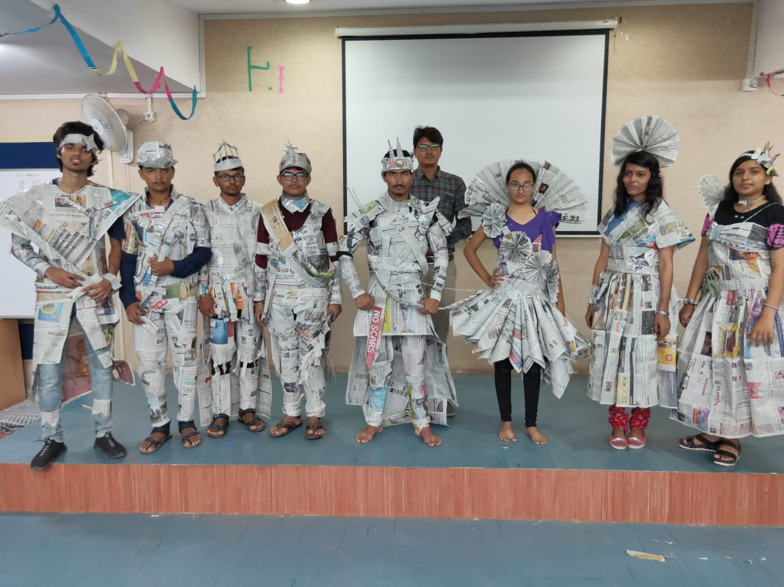
All Participants
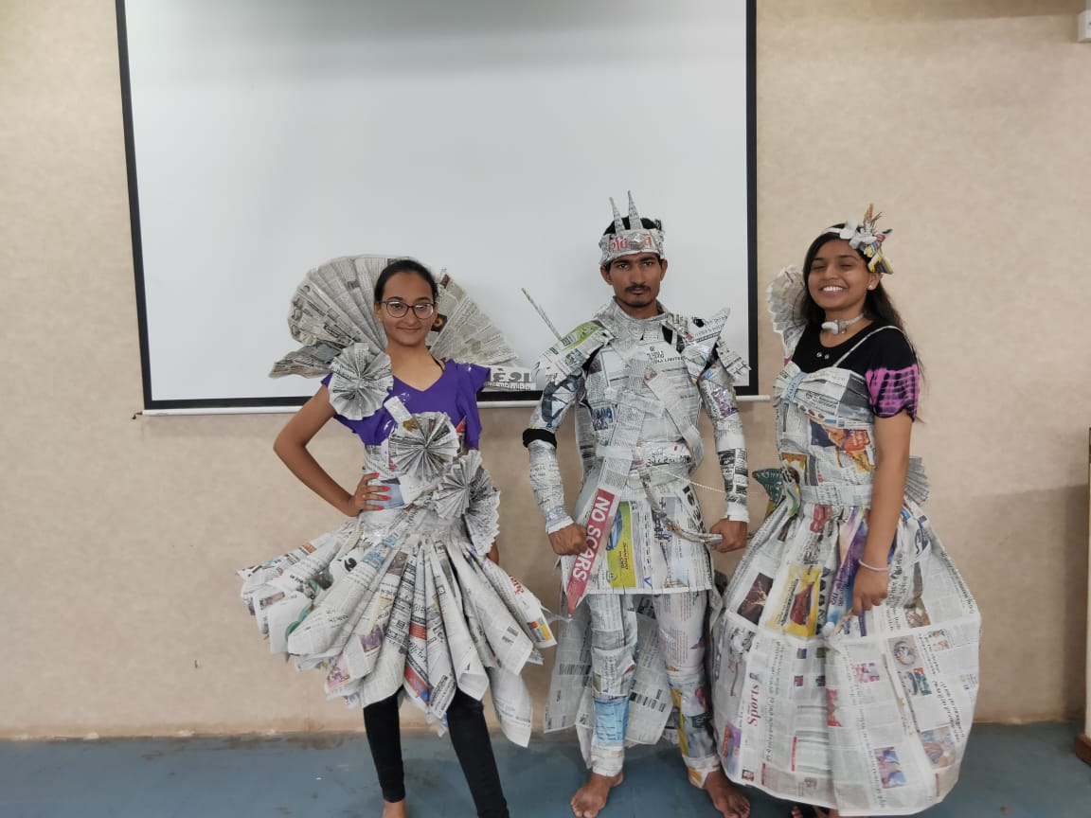
Winners

